Final Sprint Review and Retrospective

Amanda Jacquelyn Dubois

Southern New Hampshire University

CS-250-T5578 Software Development Lifecycle 22EW5

Professor Kenneth Belcher

June 17, 2022

**Abstract**

For the past seven weeks I have taken on different roles associated with the software development lifecycle. Through my experiences I have been able to summarize, analyze and draw conclusions about what worked and what did not. The agile methodology gives rise to many benefits along with the ability to work with others in all roles that make up the development team, which in turn creates a better-quality project. With the use of organizational tools and principles, I was able to gain more experience while pursuing my career. Having had the opportunity to get involved with each experience has created more drive within me. Enabling me to stay on track.

**Roles of the Scrum Team:**

Throughout this project, I have had the opportunity to take on several roles associated with the software development life cycle during the transition phase from Waterfall to Agile approach. By experiencing all different perspectives, it was shown that you need a full understanding of your role, the roles around you, and how they could rely on each other to create a quality project. Gaining better insight on how the agile methodology functions in a real-life scenario, opens your eyes to just how important communication and responsibility are throughout the entire team.

**Scrum Master:**

Starting with Scrum Master, who facilitates all exchanged information throughout the Agile improvement group. A method to this approach would be in implementing the daily Scrum Meetings, in which each team member is obligated to attend and be asked three specific questions:

* “What did yesterday’s schedule entail?”
* “What will be next on the list for today?”
* “What is impeding your progress?”

Holding these meetings created more openness within the lines of communication for the team. In addition, the Scrum Master is assigned to mentor and coach alongside the development team to help with the advancement of further understanding the Scrum theory, practices, guidelines, and abilities. Responsibility for facilitating the planned Sprint meeting would also fall into the hands of the Scrum Master.

A Sprint is a time-box of one month or less where close to the end something is done, usable and possibly complete an endeavor expansion. There are five parts that make up a Sprint and they are:

1. Sprint Planning
2. Daily Standup Meetings
3. Project’s Progress/Investigation
4. Sprint Review
5. Sprint Retrospective

With an end goal in mind, Sprint’s should have a better understanding of what is to be accomplished within the specified time frame. In the process of a daily planned Sprint meeting a flexible plan is developed to set up for success in meeting the goal at hand. A flexible plan that is facilitated by the Scrum Master along with the help of the development team is developed. To ensure a better understanding, the Scrum Master teaches the team how to further progress towards the goal while working in a specific time frames. Once the Sprint comes to an end, the next to be held is a Sprint review. At the time of the sprint review, the team collaborates by using this questionnaire:

* What was done during the Sprint?
* What has yet to be done?
* What issues did they run into?
* What solution was used to solve the issues at hand?
* What comes next?

Giving rise to the Sprint Retrospective as the team then reunites to review and hopefully improve upon the next Sprint. As a supporting role should, the Scrum Master is responsible for a ensuring the meeting will maintain good productivity. Agile is known for improving what lies ahead, therefore, this approach can help the team in realizing where improvement can be made.

**Product Owner:**

Another role I was given is Product Owner, which is more of an upper management role. It is the main face of the development team and deals directly with the client. As Product Owner, I was responsible for developing user stories along with the product backlog, which can be achieved by holding interviews and user meetings. My line of focus was set on understanding that I was accountable for maximizing the value of the project as well as being able to direct all team members. Meeting with potential customers/users, I was able to make sure the goals were clear on what needed to be achieved and that the vision is aligned with the business objectives. Directly connecting to the users ensured more perspective on challenges and any other opportunities needing to be addressed. Next, I was able to establish five requests that was simply laid out for the development team, ensuring everyone is on the same page for tasks to be performed, the goal accounted for, and the type of user this product is best suited for. All information gathered was then stored into the product backlog and organized by priority. The development team then adjusts the product backlog in order to satisfy each team member, which encouraged open communication along with creating vested interest within the project. The Product Owner holds responsibility for ensuring a backlog that is undeniably direct and transparent to everyone. Most of which will help to improve the estimation of the work being gathered and setting clear essential tasks for the endeavor.

It’s no doubt that the job entails a high level of importance, which is the key to successfully starting any agile development project. As the intermediary between the client and the development team, it was essential to ensure that the vision was understood, allowing for good team collaboration that would make any agile project a success. By visualizing the workload in a more efficient manner, I was able to simply develop both the product backlog and user stories which led to better organization along with an increase in productivity.

**Tester:**

Subsequently, I took on the role of the tester. This role entails that all user stories gathered from the Product Owner is utilized to create test cases that will ultimately determine when the user story is complete. Upon the start of the agile development process, testing is continuously being performed to provide immediate feedback for the development team. This approach will quickly determine the success rate of the project in a timely manner, meaning the team may realize they are doomed to fail, but will be able to quickly accept this as the result and move forward. More specifically, the “acceptance criteria” is a better indicator and is where most of the useful information would come from. Providing better realization of that which will not work, how to use time efficiently, and the overall expense of the project. By building the test cases for developers, helped equip them with better understanding as to what the project needs to further provide and be accepted in order to pass the test cases.

Upon the retrieval of the user stories from the product owner, additional information may still be required. Prior to the start in development of the test cases, a tester can stay in contact with the product owner in terms of clarification. A scenario that occurred during my role as the tester, entailed obtaining more information from the product owner. The following displays the email I sent in hopes to retrieve the missing pieces of information:

“Dear P.O.,

After reviewing all user stories, I began developing test cases for the different features that have been selected. For me to be more precise, I would like to request more depth in detail that I can use upon creating the test cases.

User Story #2:

* What types of filters should go in the personal profile section? Should this be in a check box format?
* Are we allowing the user to specify their price range? If not specified, then would all vacations of any budget be shown?

User Story #3:

* Should the list of deals start with the most popular, along with ending with the least popular?
* Can users rate deals?
* What column header design will be used within this section?
* In pursuit of seeking deals, would it be wise to enable an option(s) to further sort out the deals that are displayed?

User Story #4:

* Should all results acquired for top destinations be listed on the same page and navigated through with a scroll bar function?
* What is a good length for the descriptions that are describing each destination? Should a caption be included at the bottom of each picture?
* Will the most popular destinations be listed, starting with #1 and continuing with the rest of destinations or should it be reversed?”

**Developer**:

The developer plays an important role within the development team by including many aspects. Featuring the designing and testing of software, interacting with users/testers along with product owners where it is deemed necessary, and holding responsibility for the software they created by cooperating with each other in the means of communicating effectively. My role as the developer involved overseeing parts of the project work the way the user stories wanted and taking the feedback from the testers to enhance them. This project consisted of a slideshow which needed some implementations due to the requests of the travel agency. Due to the unexpected requests if it wasn’t for the agile approach, then it could have very well ended in failure.

Agile methodology enables a developer to be more flexible in their approach to development thanks to its adaptable nature. With the requirements of the project at hand changing, I was able to at least quickly adapt to the Agile mythology and escalate quickly through the responsibilities required of the developer. One of the key elements to developing within an Agile environment is by working with code efficiently. Thanks to the Agile methodology, the requested implementations were encouraged to establish a higher quality product overall. Adaptation was met rather quickly due to efficiently working on the code in a manner that not only saved time, but energy too.

Having to refactor the code rather than advancing straight through the first time, could be seen as enervating, yet it does grant for more freedom and innovation during the development process. Changes made will be updated at every level, such as product backlog, user stories, test cases etc. and the developer will continue coding while simultaneously editing when it is best. In acquiring detailed responses that will enable my team to move forward, specific questions should be asked regarding functionality and desired outcomes. As changes will be made, especially when utilizing agile methodology in which implementations and updates will occur along the way, plenty of room will be made to adhere to such.

Allotting a block of time specifically geared for changes in features or other aspects that the client or product owner may decide to modify will require proper estimation. Most user stories are seen as being more of “place holder for conversation” while the developer is expected to interact with the product owner, tester and users while applying any significant changes made to the project goals.

My experiences of playing a part in each role along with the approaches I took for each task were due to the adaptation of the agile method. While both the waterfall and the agile method have their own merits depending on the project, choosing the agile method for this project was the more suitable approach due to anticipated changes that could arise, undefined product details, or a need to rapidly deliver efficient software. Some of the main organization tools that aided my endeavors were Sprint strategies, standup social occasions, customer stories, excess and tests. A specific gadget that was encountered during this course as the Scrum Master was the Charter. The Charter is a report that builds up the structure for the data gathered during the process of project completion. This tool creates efficiency as the developer can work more smoothly. Another useful tool that would help the team stay organized is in implementing daily meetings. The meetings would enable constant feedback and collaboration for all involved, keeping everyone on the same page.

Communication between the team is a huge factor when it comes to the success of any project and one method worth noting is the product backlog. The product backlog is a vital tool to be utilized as it enables users/developers to know what has and has not been completed along with the levels of prioritization of each item. Gaining the information above will be considered quite helpful in staying on track and ahead of the deadline. Without a product backlog, the development team is at risk for skipping a step/phase and not realizing till it is too late.

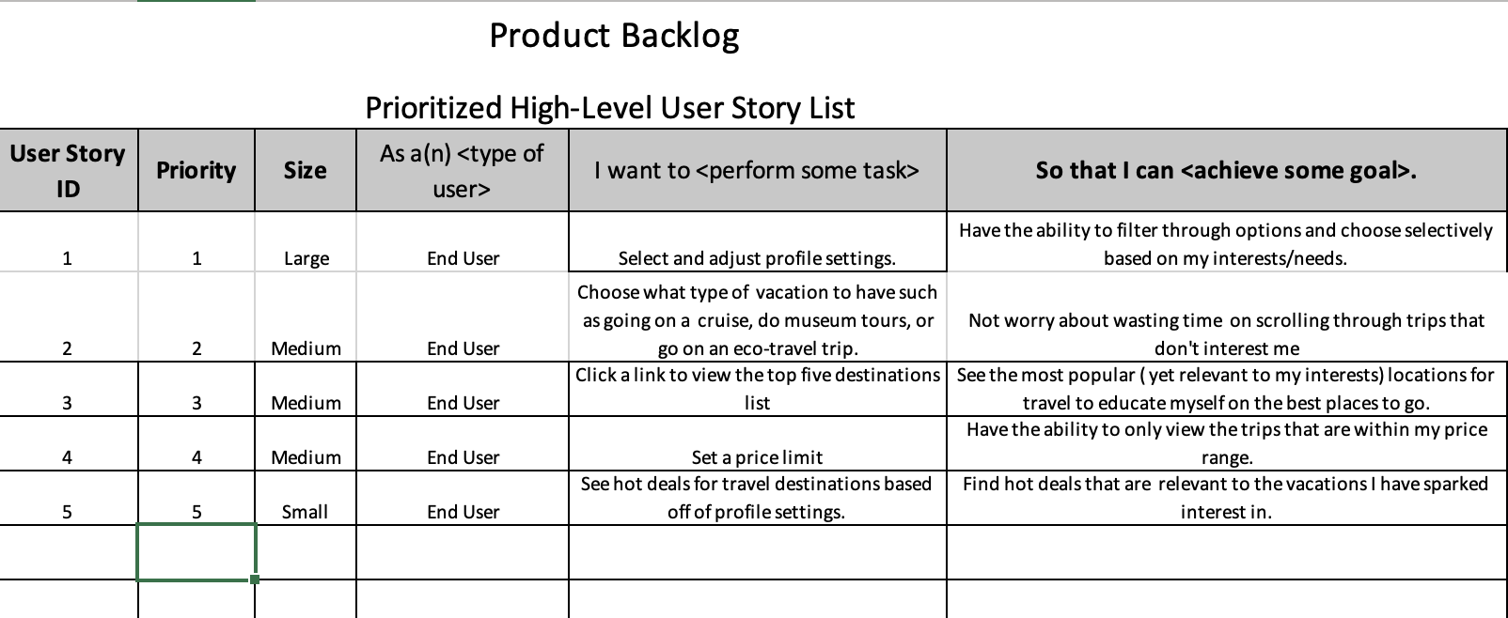

**Future:**

My future endeavors entail me stepping my foot in the door of an IT company to add to my experience and potentially become an independent software developer someday. The tool I found most helpful and will most likely use in future projects would be the product backlog. With a little tweaking the product backlog can provide that backbone by having the ability to take note of what is done and what still needs to be done. This will help me maintain a more organized daily/weekly schedule in which I will be more likely to complete all tasks without skipping by mistake.